Haverford Green Office Program
Our department/office is________________________________________ and we are applying for “________________ Squirrel” certification.
(silver, gold, green)

Once certified, Claudia Kent will deliver certificate, light plates and stickers to the Green Representative.

Silver Squirrel
To receive a Silver Squirrel award all of the following must be met:
The department’s Green Representative must initial each of the following statements to achieve credit.
Participation
_____One person from each department is selected to be the Green Representative and contact person for the program. While open communication is always encouraged, periodically a Committee on Environmental Responsibility (CER) member will make contact for evaluative purposes and to provide additional information.
________________________has selected ______________________ to be our department’s green
(Department) (Name)
representative. Their email address is: ___________________________.

We have______________ staff and _____________ students working in our department.
We have ____________ faculty.
___________% of our department is willing to participate in the Green Office Program.
Energy Conservation:
_____We turn off all lights when they are not in use during the day and at night. In order to ensure that lights are turned off, we place labels or cover plates provided by Claudia Kent on switches as reminders.
_____We send a reminder to staff before breaks to turn off electronic devices before leaving. Download the PDF
Waste Prevention and Purchasing:
_____ Our printer defaults are set as double-sided duplex printing.
_____ The printer paper that we buy contains at least 30% recycled content.
_____ We encourage all of our staff to use mugs or recyclable cups for daily use.
_____ If we supply paper products for our kitchens or break rooms, we purchase materials that have at least 30% recycled content. If you do not provide paper products for your kitchens or break rooms, please initial here_____.
_____We use interoffice instead of regular envelopes whenever possible and promote the redistribution of inter-office envelopes in our office or department.
Recycling:
_____ We have clearly labeled paper and plastic recycling bins present in all common areas.
_____All of our electronics are properly recycled. Email IITS at prodesk@haverford.edu for more information.
_____ When we need to dispose of office furniture, we contact Director of Purchasing, Nikki Millas to see if it can be salvaged and reused elsewhere. Email: nmillas@haverford.edu
_____We recycle our small printer cartridges in the green 5-gallon trash can in the Dining Center Lobby.
_____We recycle our copier toner cartridges in the yellow 30-gallon container located in the Dining Center Lobby.
_____Batteries are recycled in the Dining Center and Campus Center Lobbies in the red 5-gallon trash can.
Transportation:
_____ We feel that there are adequate bike racks for faculty, staff and students located near the building. If not, we have contacted Facilities Management to see if obtaining new bike racks is a possibility.
Gold Squirrel:
In addition to the requirements of Silver Squirrel, to receive a Gold Squirrel award all of the following must be met:
Energy Conservation:
_____If we use PCs, I understand that energy saving settings are established centrally by IITS and administered remotely.
_____If we use Macs, the following settings are recommended for energy savings. We do not shut down our computers at the end of the day.
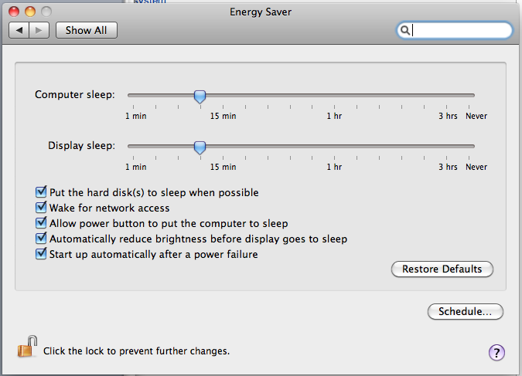
_____ As incandescent light bulbs burn out we request CFL (Compact Fluorescent Light) bulbs from either Facilities Management at facilities@haverford.edu or Claudia Kent, Sustainability Coordinator at ckent@haverford.edu
_____ We close all windows at the end of the day.
_____ If we have control of daytime temperatures, we set the thermostat to 68° F in cold weather and78° F in warm weather.
_____ When we dispose of old appliances, we request the purchase of EnergyStar or EPEAT-certified appliances as replacements.
_____We unplug cell phone chargers when not in use.
Waste Prevention and Purchasing:
_____ At least twenty percent of the printer paper that we buy contains 100% recycled content.
_____We require all of our staff to use mugs for daily use.
_____ For all printing completed outside of our department/office, we ask whether Forest Stewardship Council (FSC) certified paper is available for use.
_____ For all printing completed outside of our department/office, we ask our external printing contractor to use paper with at least 30% recycled content.
_____ We only use reusable water bottles.
_____ We use non-disposable plates, silverware, and cups in the break room.
Green Squirrel:
In addition to achieving a Silver and Gold award, to receive a Green Squirrel award all of the following must be met:
Waste Prevention and Purchasing:
_____At least three other items that we purchase frequently (i.e. pens, notepads etc…) contain at least 50% post-consumer material.
_____At staff meetings and events held by our office/department, we use non-disposable or recyclable plates, silverware, and cups. We also encourage attendees of the meetings and events to bring their own non-disposable plates, silverware, and cups.
Recycling:
_____We offer recycling at all meetings and events, and notify attendees of meetings and events of the proper location to recycle materials.
Transportation:
_____Information on Transit Chek has been distributed to everyone in the department. More information can be obtained from Pierrette Picard at ppicard@haverford.edu
_____We actively encourage that our staff reduce the number of SOV (Single Occupancy Vehicle) trips made by our staff.
_____We provide our staff members with current transportation options (SEPTA, Amtrak, Bolt, Chinatown buses etc.)
_____We encourage the use of Philly Car Share if we are leaving campus.
Participation:
_____Our department is in-touch with the CER if we have any questions regarding anything about the Green Offices protocol. We offer at least one suggestion per semester regarding green practices on campus on the CER’s suggestion box online. Visit the Suggestion Box >
For more information on green purchasing, please visit Haverford College’s Sustainability website at http://www.haverford.edu/greening_haverford/sustainable_campus_operations/green_purchasing.php

